SE LAB 2
PES1UG24AM215
Raghav G Uddihal

Backlog List:
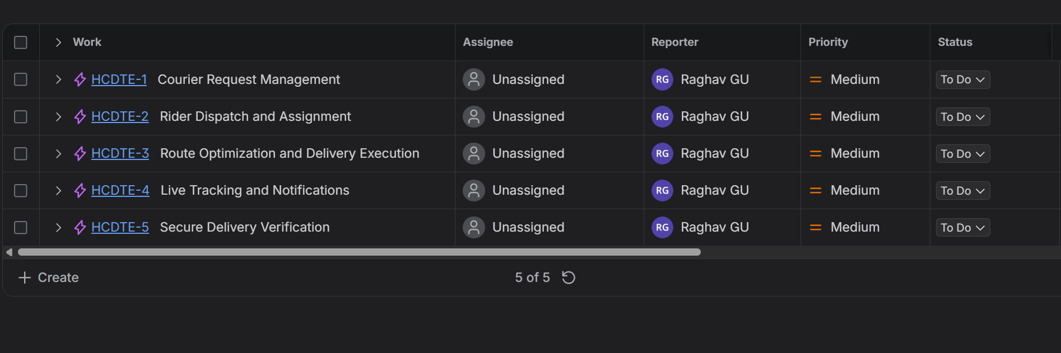

Courier Request Management:
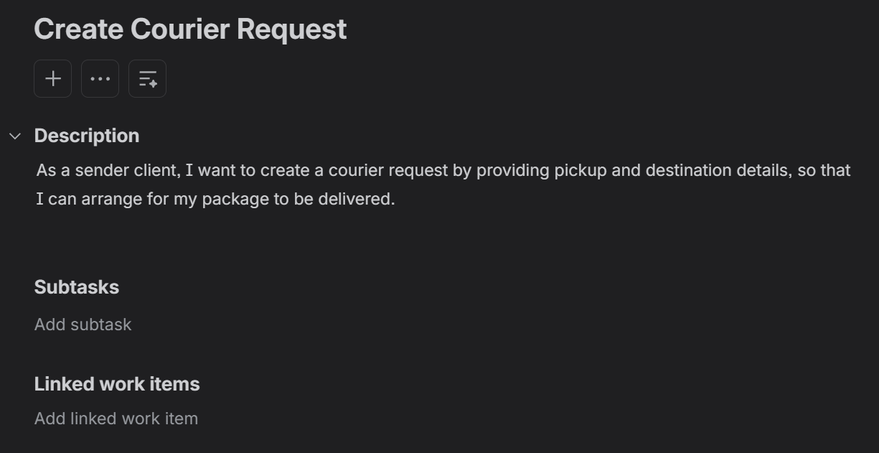
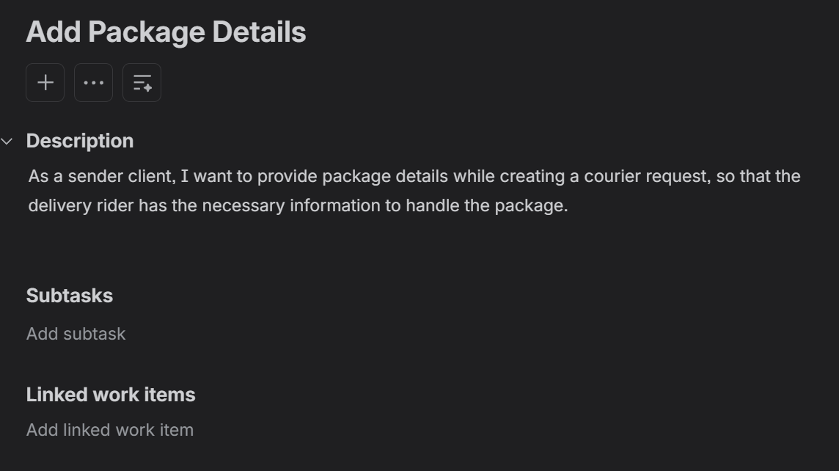
Rider Dispatch and Assignment:
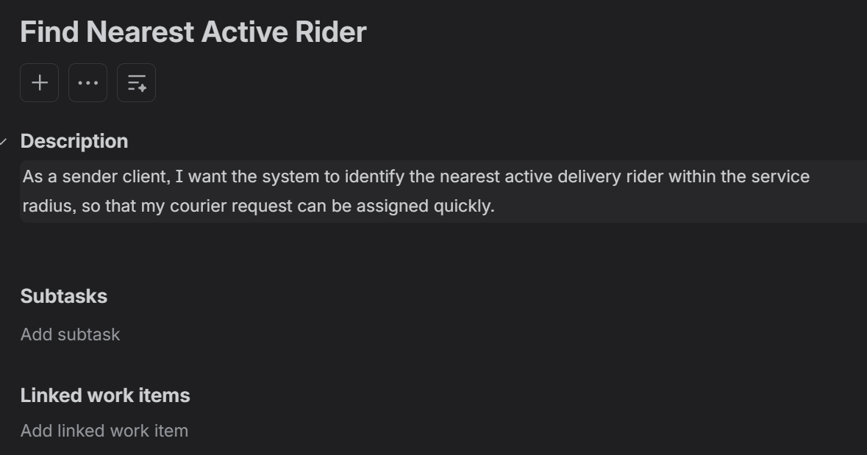
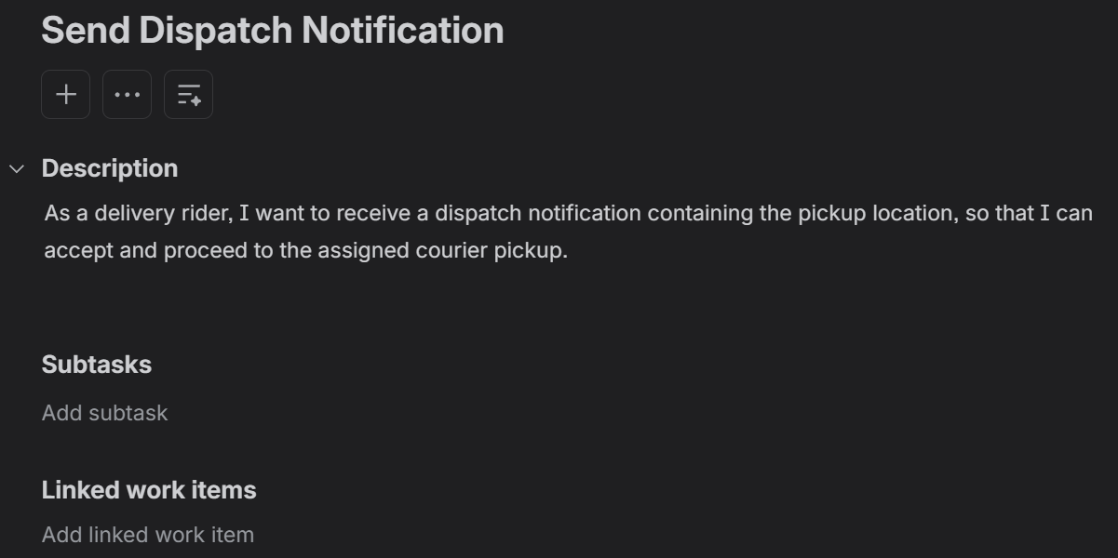
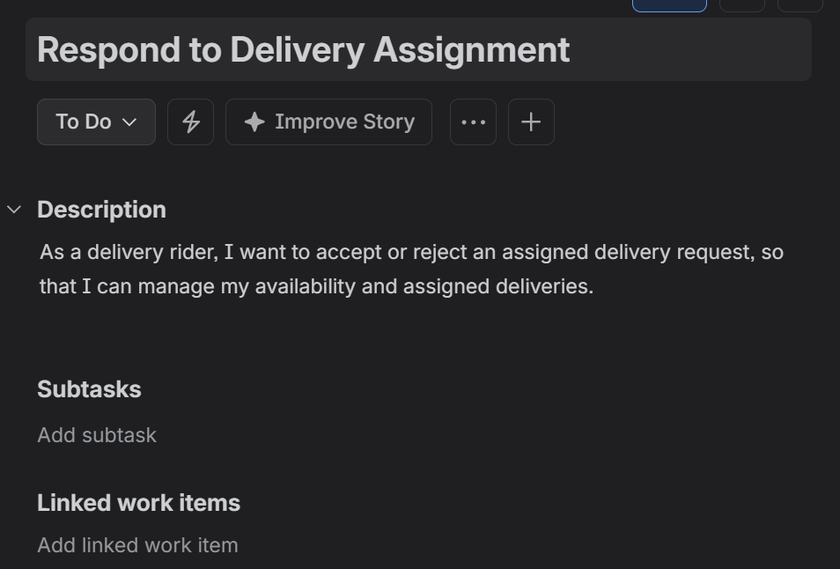
Route Optimization and Delivery Execution:
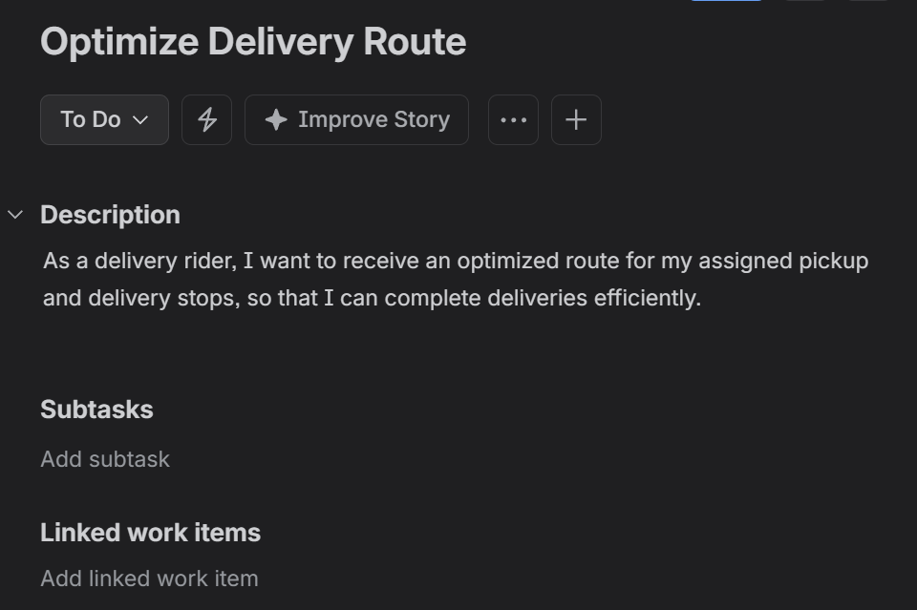
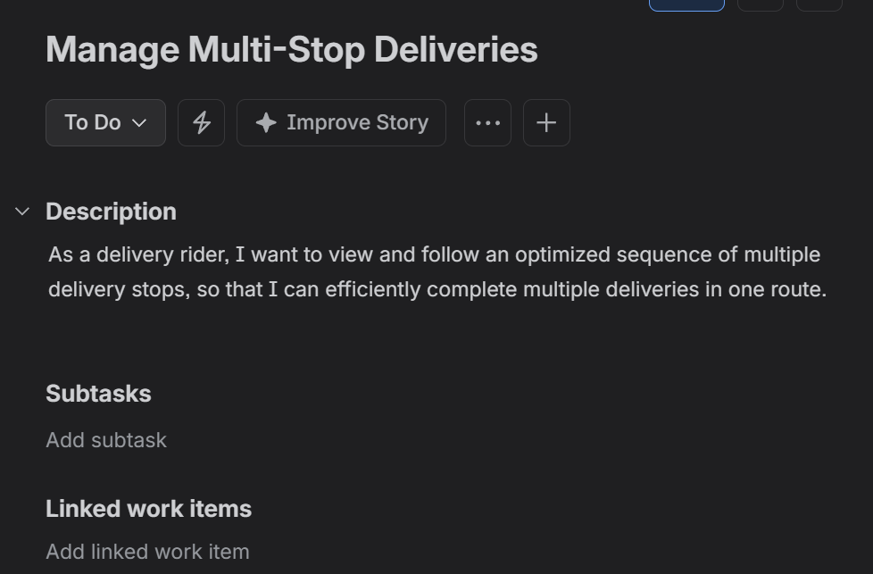
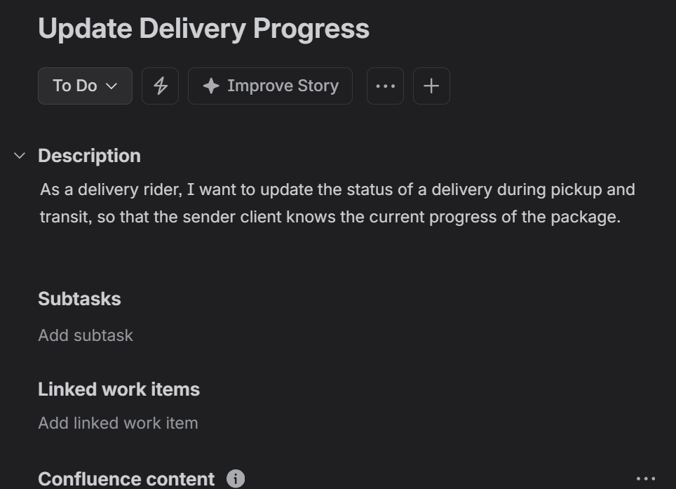
Live Tracking and Notifications:
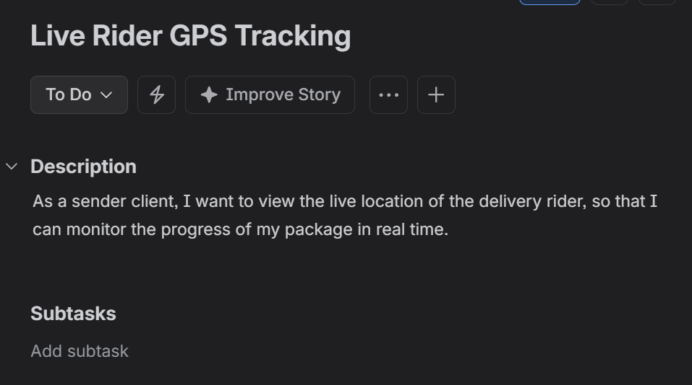
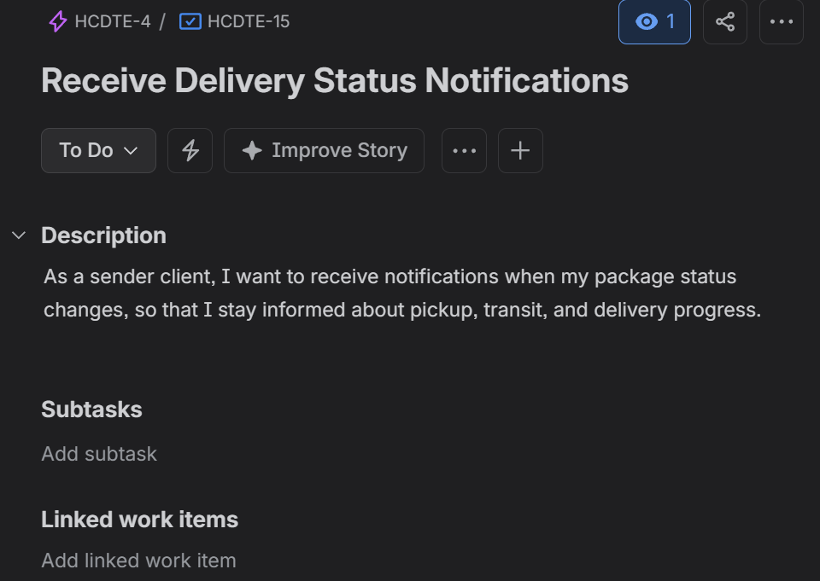
Secure Delivery Verification:
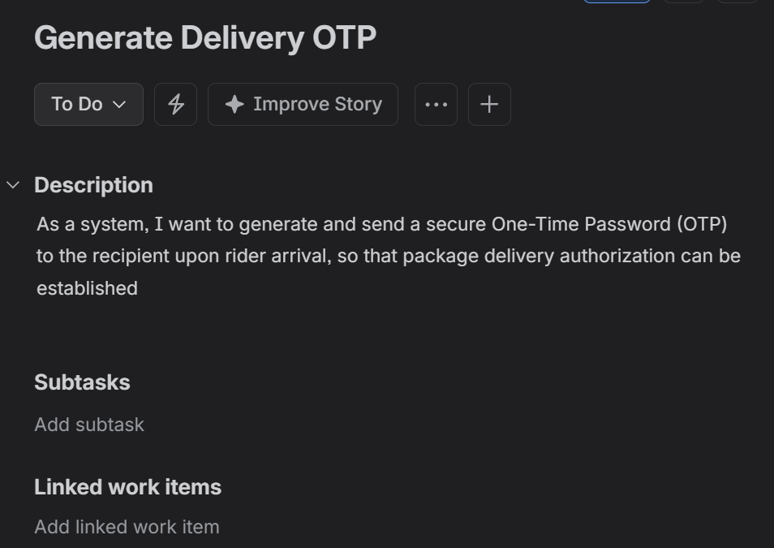
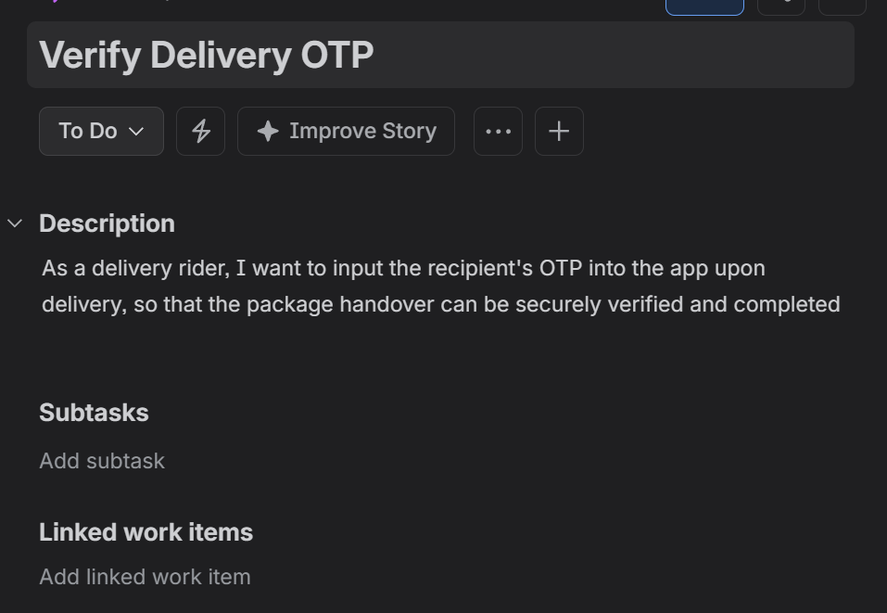
Sprint 1 Outputs:
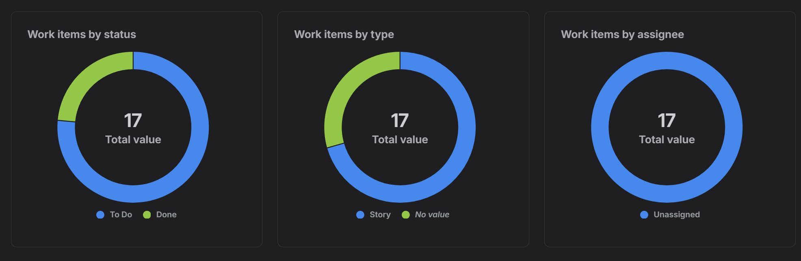
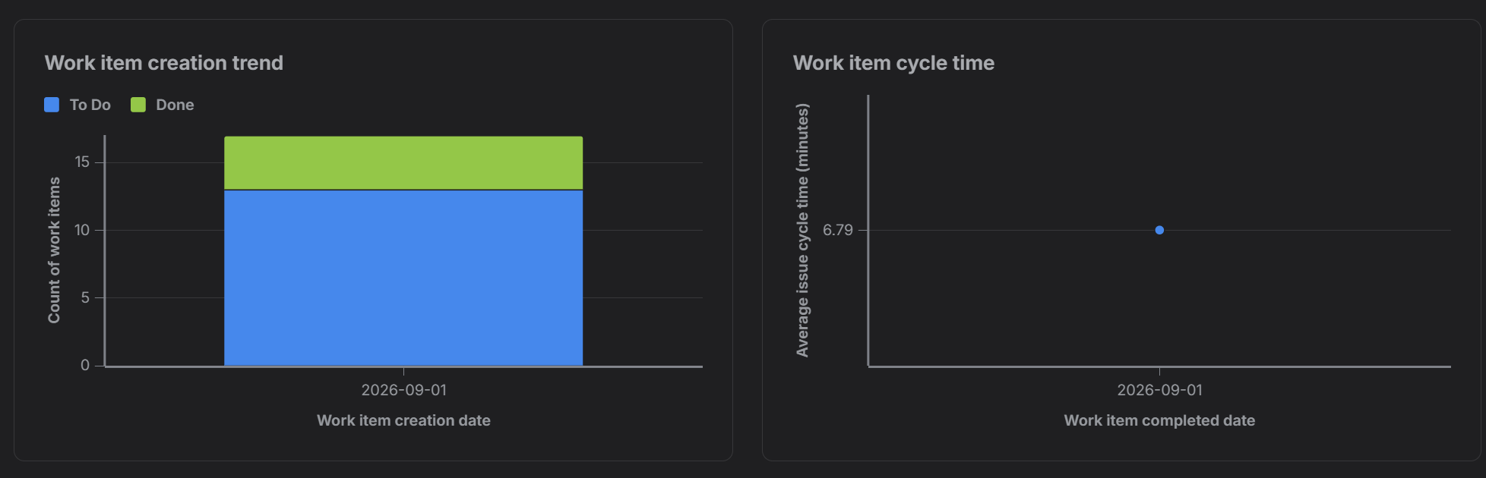
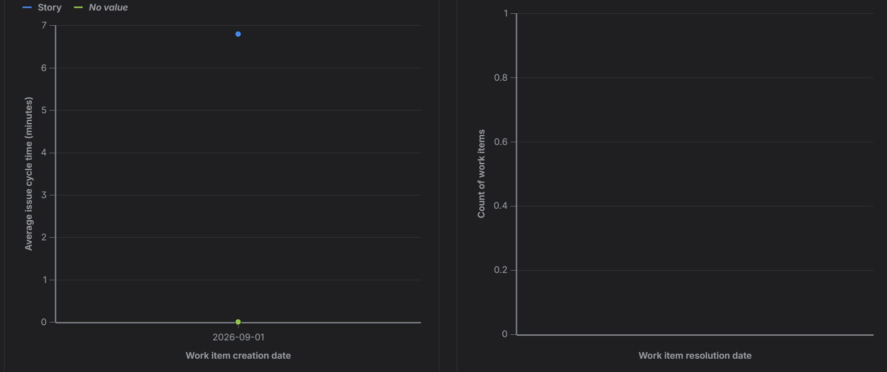
Sprint 2 Output:
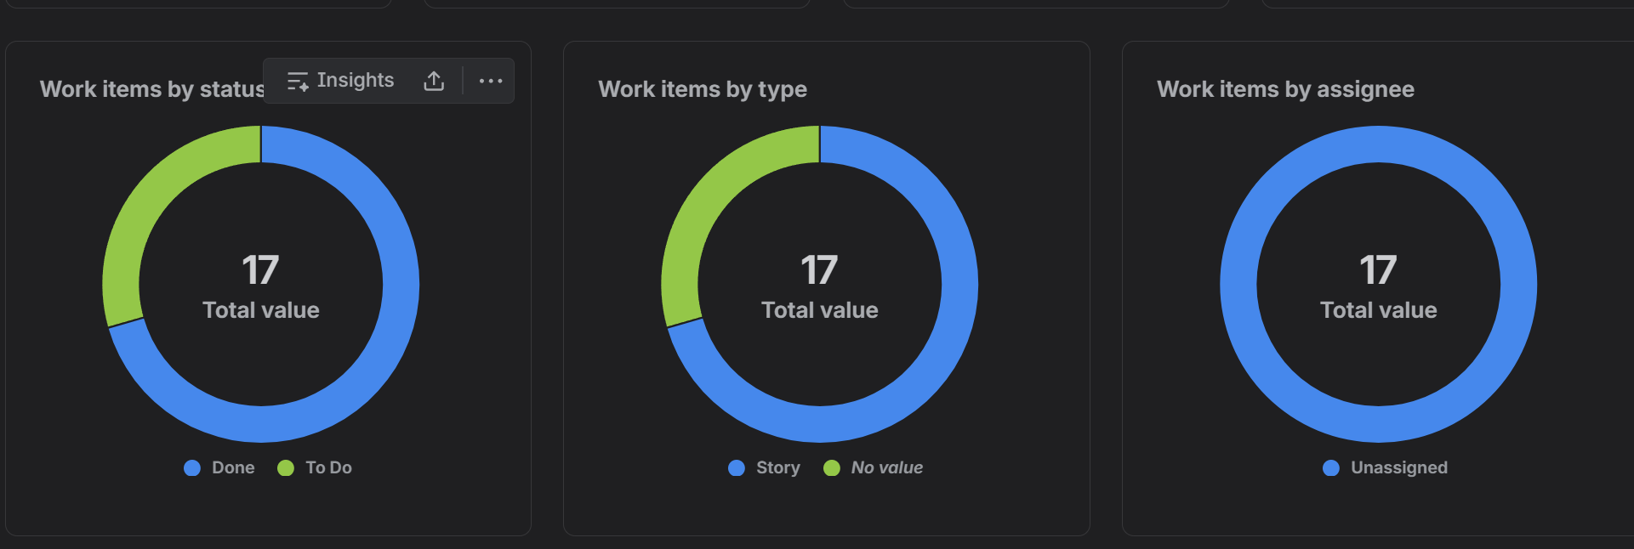
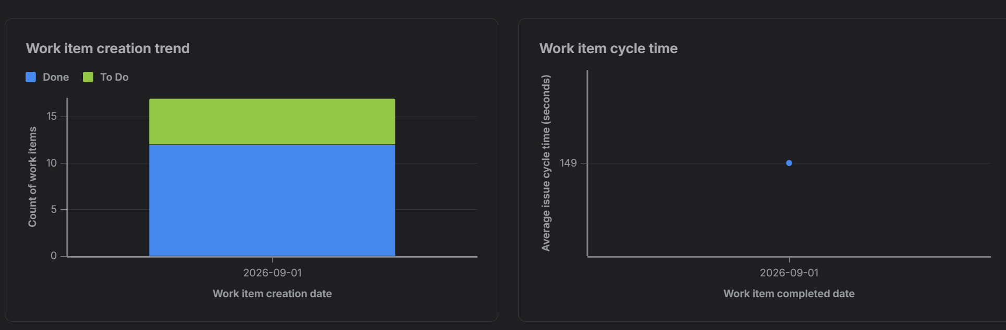
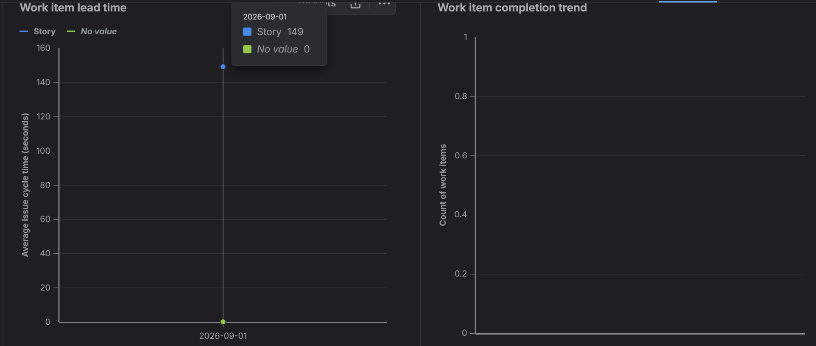

Sprint Reflection:
Sprint 1 Reflection
- Focus & Execution: Focused successfully on foundational infrastructure, establishing core request ingestion schema and nearest-rider assignment logic.
- Velocity & Flow: Smooth team rhythm transitioning items from backlog through the initial pipeline, validating that basic payload structures and driver matching algorithms functioned correctly under mock conditions.
- Outcome: Clean execution with zero technical blockers, wrapping up the initial set of foundational stories right on schedule.
Sprint 2 Reflection
- Focus & Execution: Tackled complex downstream features including multi-stop management, real-time WebSocket GPS telemetry, and secure OTP verification handshakes.
- Velocity & Flow: Handled a heavier load of 8 simultaneous stories, successfully synchronizing background geolocation tracking with client-facing UI state updates.
- Outcome: Completely closed out all remaining project epics, successfully achieving end-to-end delivery automation from initial request generation to final verified handover.
Group Reflection:
Group Reflection: Alignment of Agile Framework Structuring the hyperlocal courier dispatch and tracking engine across 5 distinct Epics allowed us to cleanly decouple foundational request ingestion and rider dispatch (Epics 1–2) from advanced routing, live GPS tracking, and secure OTP verification (Epics 3–5).
Insights from Estimations and Prioritization Utilizing story point sizing helped expose technical complexity and operational risks early on, cleanly separating high-effort tasks like real-time WebSocket location telemetry and geospatial matching (8-point stories) from straightforward alerts (3-point stories). Prioritizing core dispatch workflows in Sprint 1 ensured that foundational driver-matching infrastructure was locked down before implementing multi-stop routing and verification handshakes.
Lessons Learned Tracking execution metrics through Jira's status overviews and burndown charts proved essential for maintaining steady workflow momentum. Monitoring status distributions and sprint velocity provided clear visibility into project health and ensured seamless transitions from initial request creation through final delivery sign-off.

Burndown Charts:
Sprint 1:
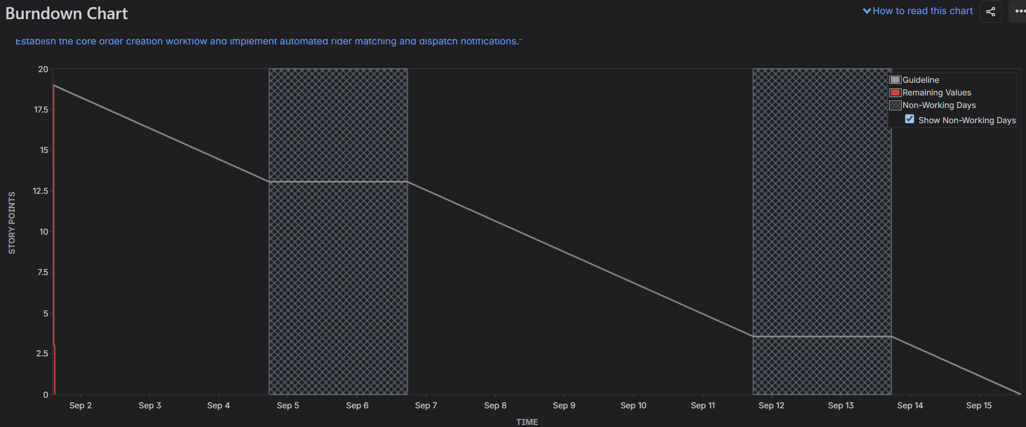

Sprint 2:
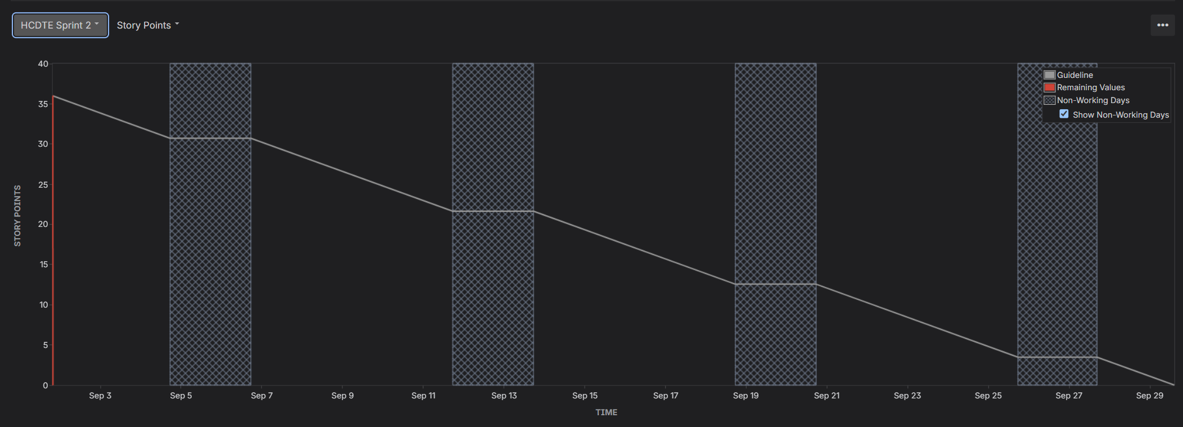
Showing Story Points ( Correction):
